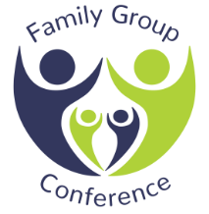

Consent form for Family Group Conference

In order to proceed with a Family Group Conference we need your consent to the referral being made and to the sharing of the contents i.e. strengths, concerns, bottom line and goals with everyone involved in the Family Group Conference process.

Please sign below to agree your consent. You can withdraw this consent at any time.
Date
Parent/Carer/ Young Person

Signature

